**Project Diary**

**Investigations of Complex Networks**

**Supervisor J.E. MacDonald**

Kavian Shirkoohi

C1770404

School of Physics and Astronomy

Cardiff University

**Objectives**

Established on 11/10/19.

1. Develop an understanding of complex networks
2. Generate software to produce and analyse networks
3. Investigate properties of networks for a specific application

***Develop an understanding of complex networks***

Having familiarised myself the 3 documents sent by the supervisor, there is now a fundamental understanding of the characteristics and types of networks. Drawing from my Discrete Mathematics knowledge at A-Level (from the D1/D2 modules), I already have a basic understanding of the structure and optimisation of networks for specific purposes; namely finding the minimum spanning tree (MST), project allocation (Critical Path Analysis) and finding the shortest path between nodes in a network (Dijkstra’s algorithm).

***Generate software to produce and analyse networks***

I intend to generate a simple python program, using Numpy and SciPy libraries to generate an adjacency matrix which can represent the nodes and connections between them (arcs) on a random network. This can serve as a framework for further investigations and observations of changes to connectivity probability and network complexity.

***Investigate properties of networks for a specific application***

More to be filled in as the project progresses. Some ideas include medicine, military logistics, decisions, relationships, computer networks and the world wide web, functions calling other functions in computer code etc.

**Developing a basic program**

31/10/19. Using the NetworkX package to construct and illustrate a discrete-mathematics graph within Python. Below is the original code written in Python 3.0, before progressing on to formatting, adding labels for nodes and connections, and tidying up.

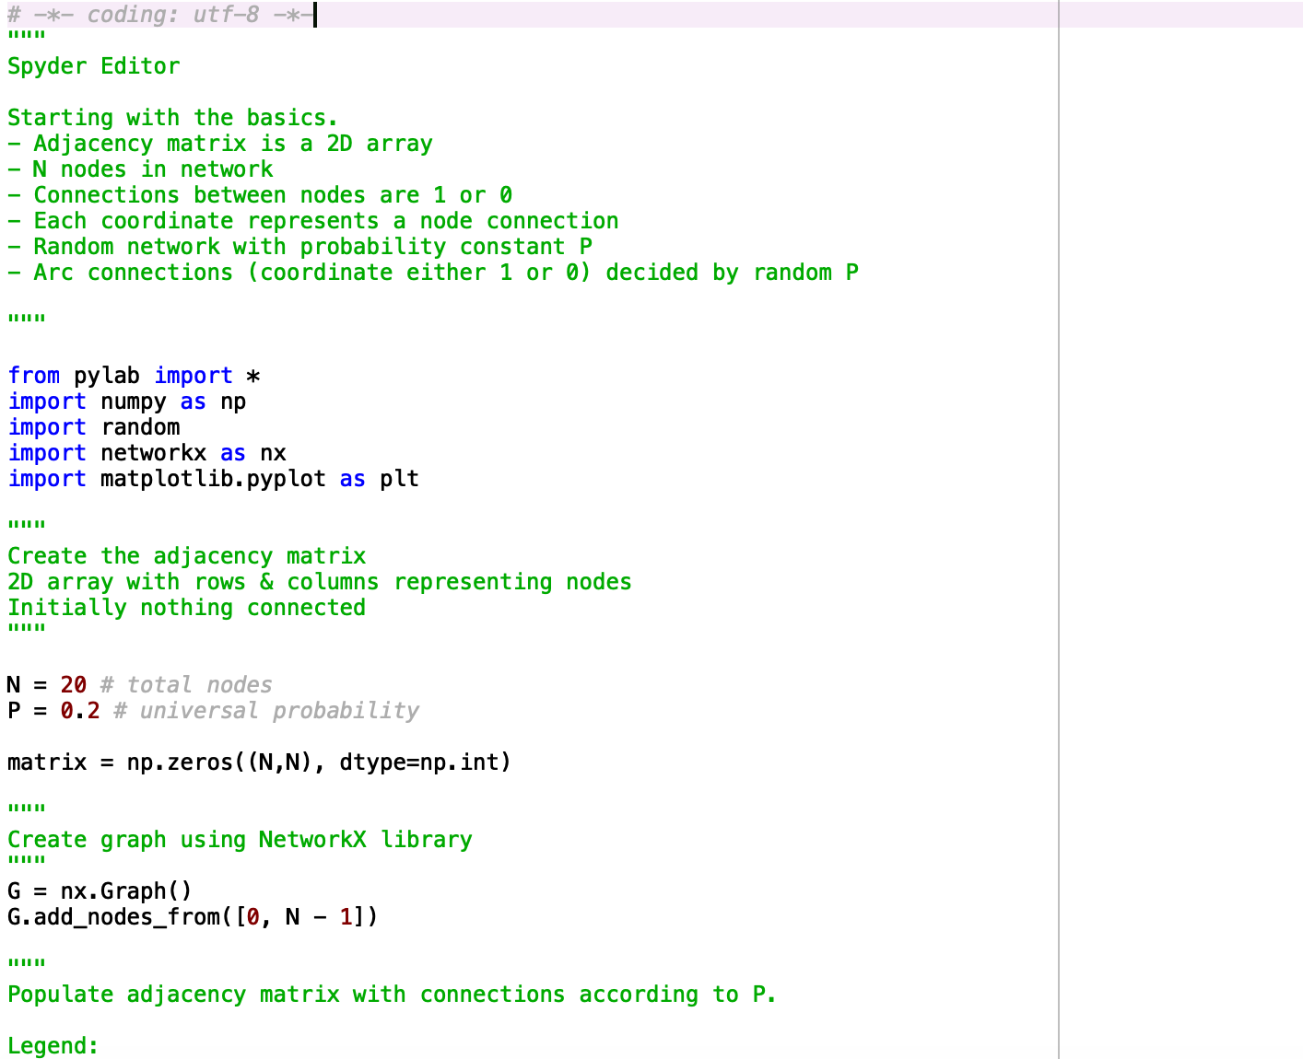

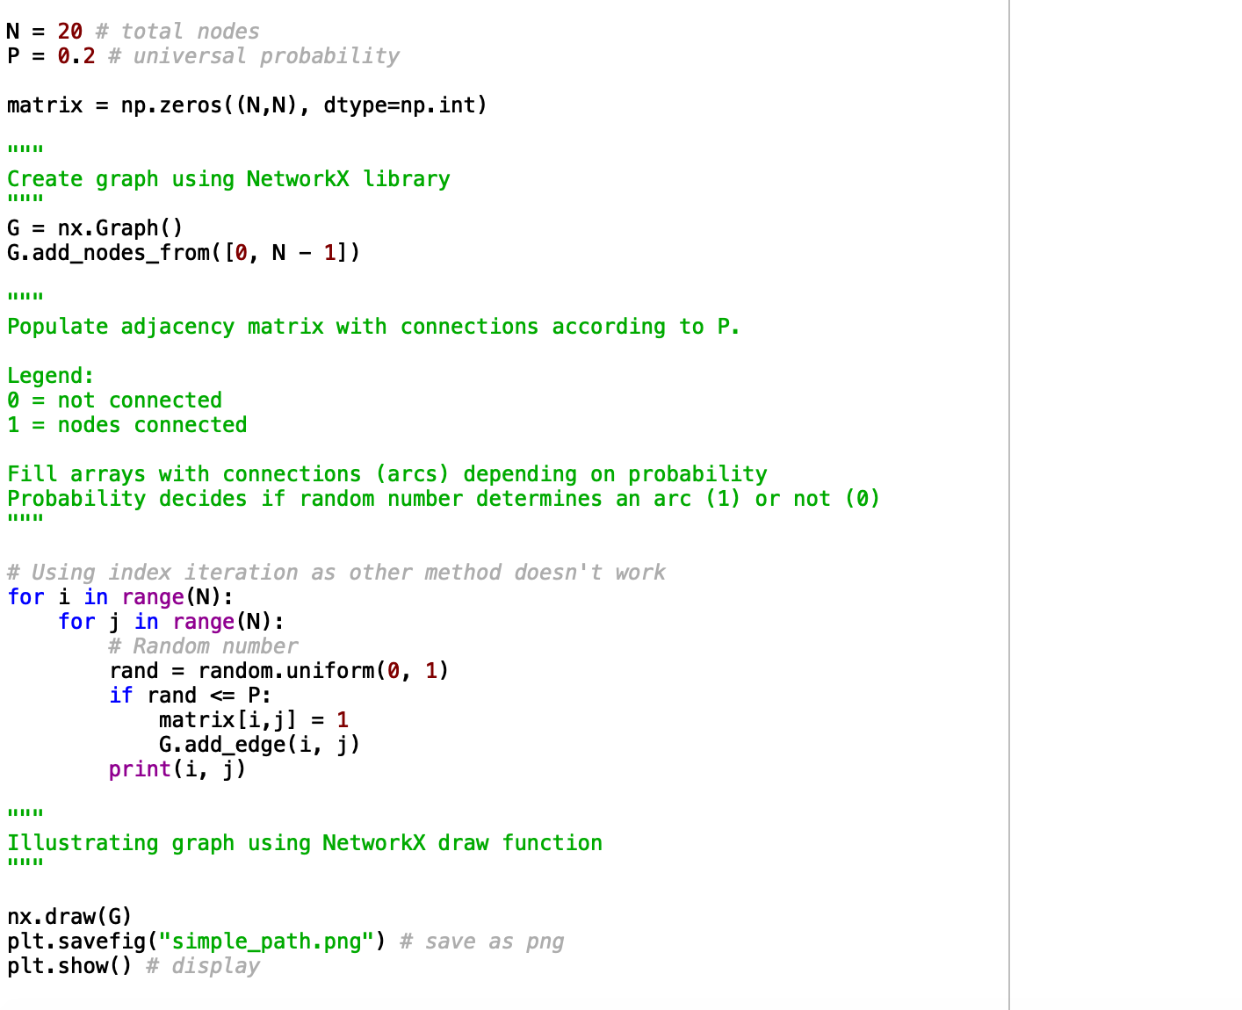

*Above code annotated throughout each step of the program. A 2D N-by-N array of zeros is created as well as a NetworkX graph with N nodes. The array is populated with ones, determining a connection between the respective nodes if, upon the iteration of each element in the array, a randomly generated number lies within the range of the constant probability P. The graph is drawn with the Network X package.*

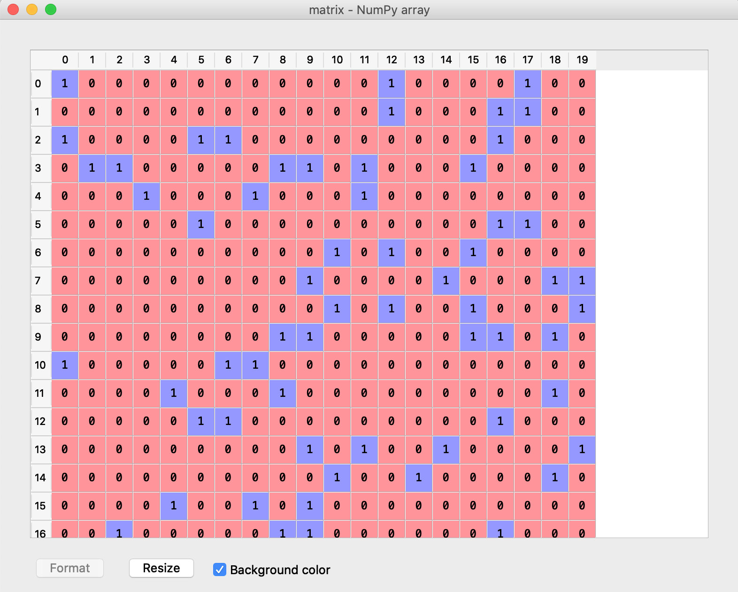

*An example of the adjacency matrix generated by the code. Each row/column represents a node. The individual elements represent a Boolean value determining whether the node A is connected to B, i.e. row A and column B having a value of 1 means there is a connection from A to B. Note this is a partial snapshot – not all rows from the adjacency matrix could be fitted within the captured element.*

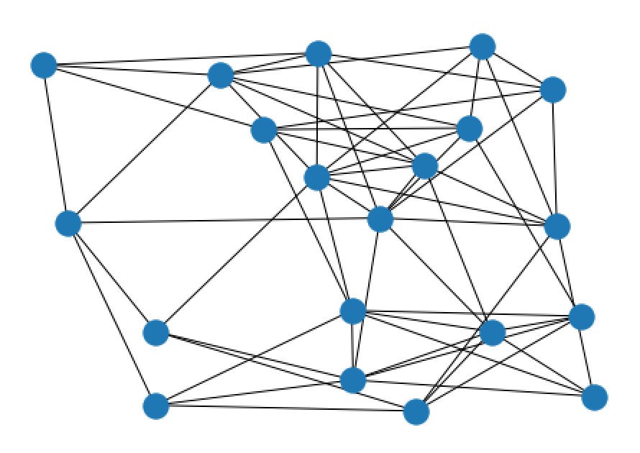

*Here is an example of a resultant graph constructed from the data above. Note that the appearance is basic at the moment, however node labelling and arc weighting may be factored in later.*

The program is capable of generating a random network of large number of nodes and being able to vary the connectivity between the nodes within the graph as a whole, to yield some interesting observations. This feature may come in useful as the project progresses for investigations of applications and phenomena such as the Small World Effect.

**Random Network**

4/3/20. Revising the code from the previous example, a final version of the random network can be demonstrated, including labels for arc weights and node labels.

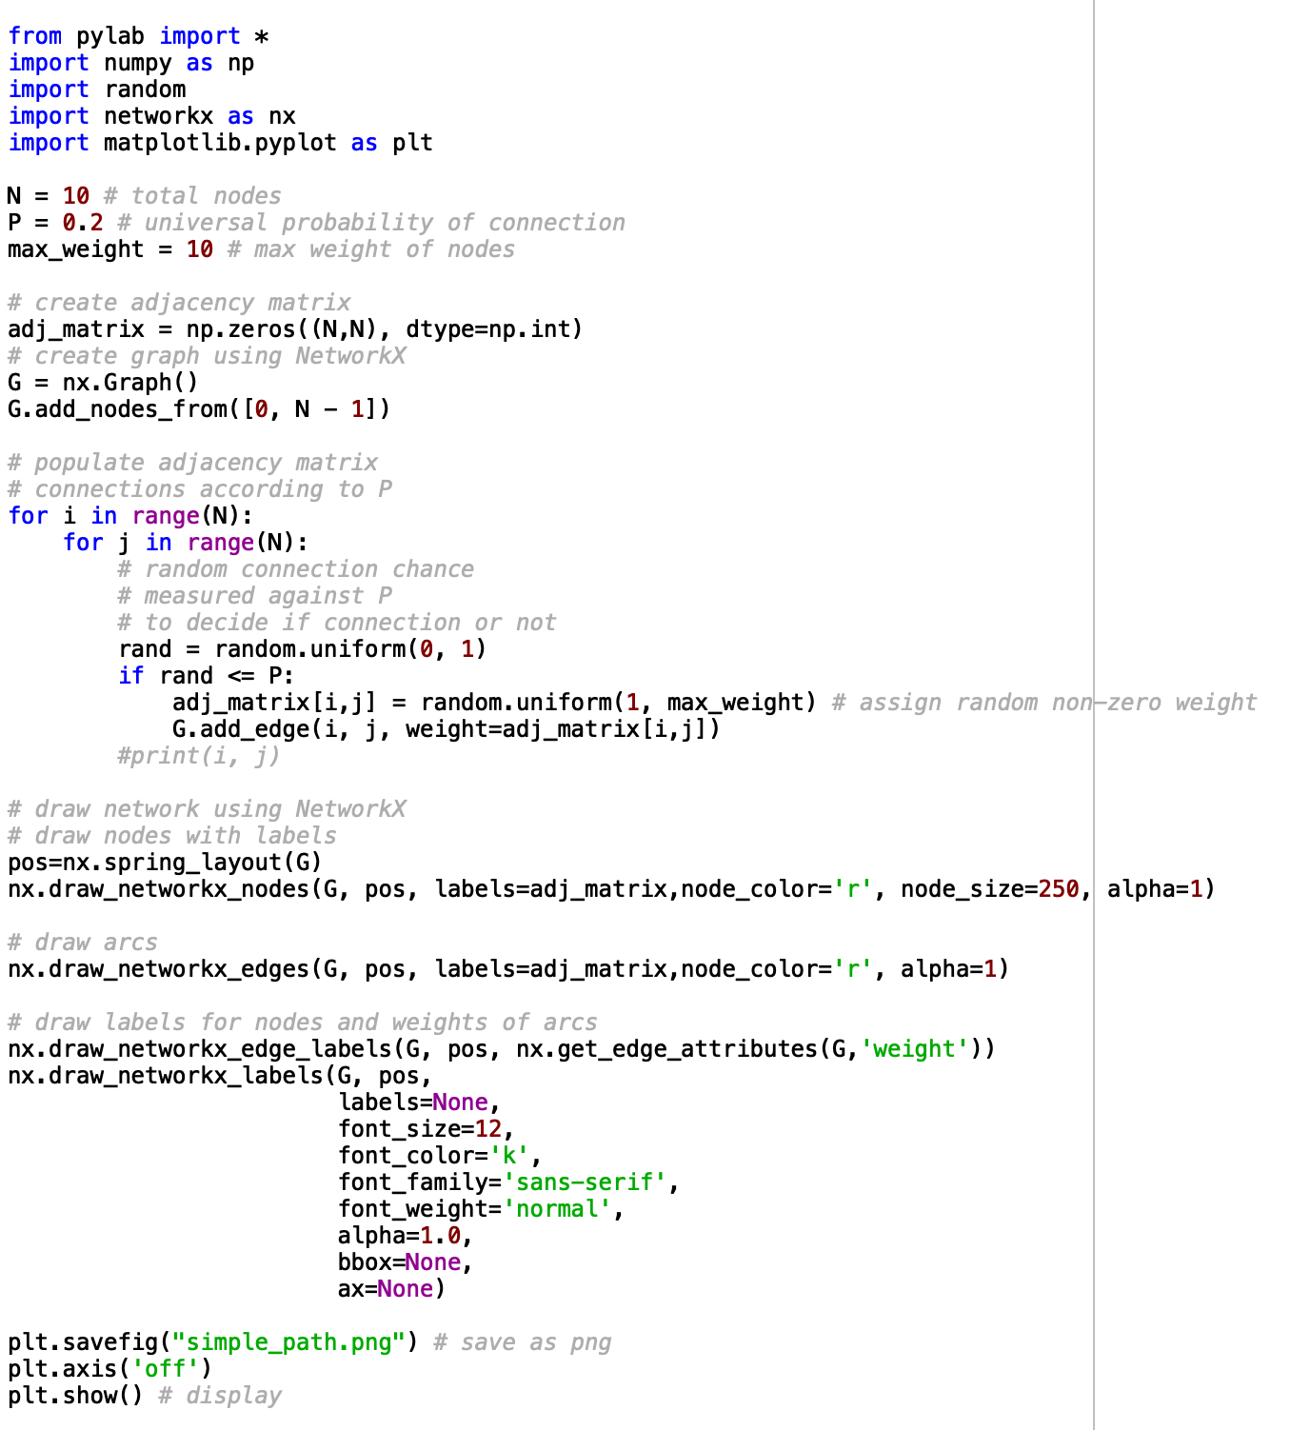

*Above code demonstrates the revised and final version of the Random Network generator, which may be used for illustration and comparison purposes later in this project.*

*Here is a figure generated by the Random Network program which illustrates the network created with labels for node identifiers and arc weights.*

**Small World Network**

The initial idea is to generate code that creates a ring network of nodes connected to their adjacent neighbours. As the number of nodes in the network increases, the adjacent connections per node increases until a maximum of a connection to 3 adjacent neighbours is realised.

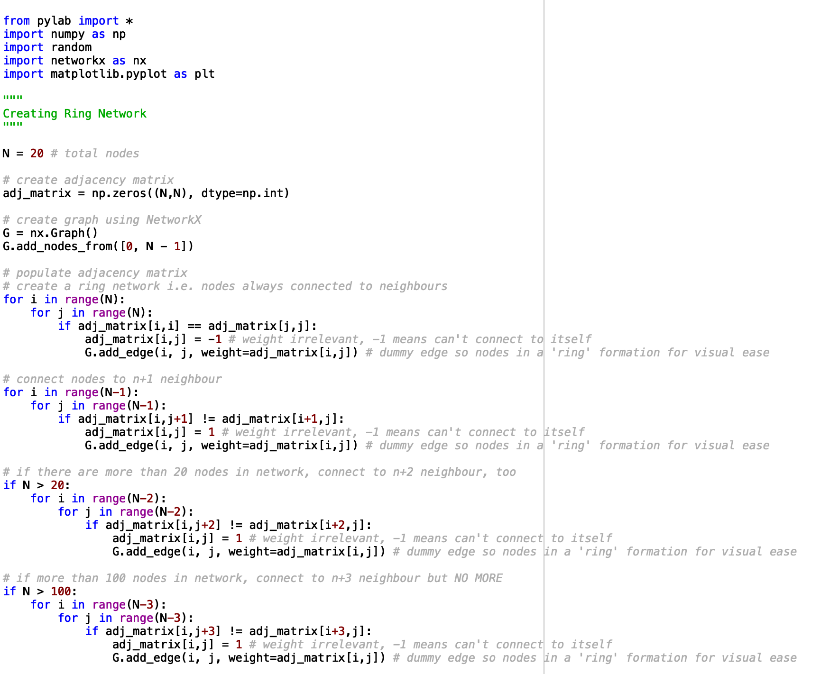

*This code generates a ring network, with adjacent connections/node order decided by the total number of nodes in the network, N. For N <= 20, every node is connected to its nearest neighbour. For N > 20, the node is connected to its nearest and its second nearest neighbour, and so on for N > 100.*

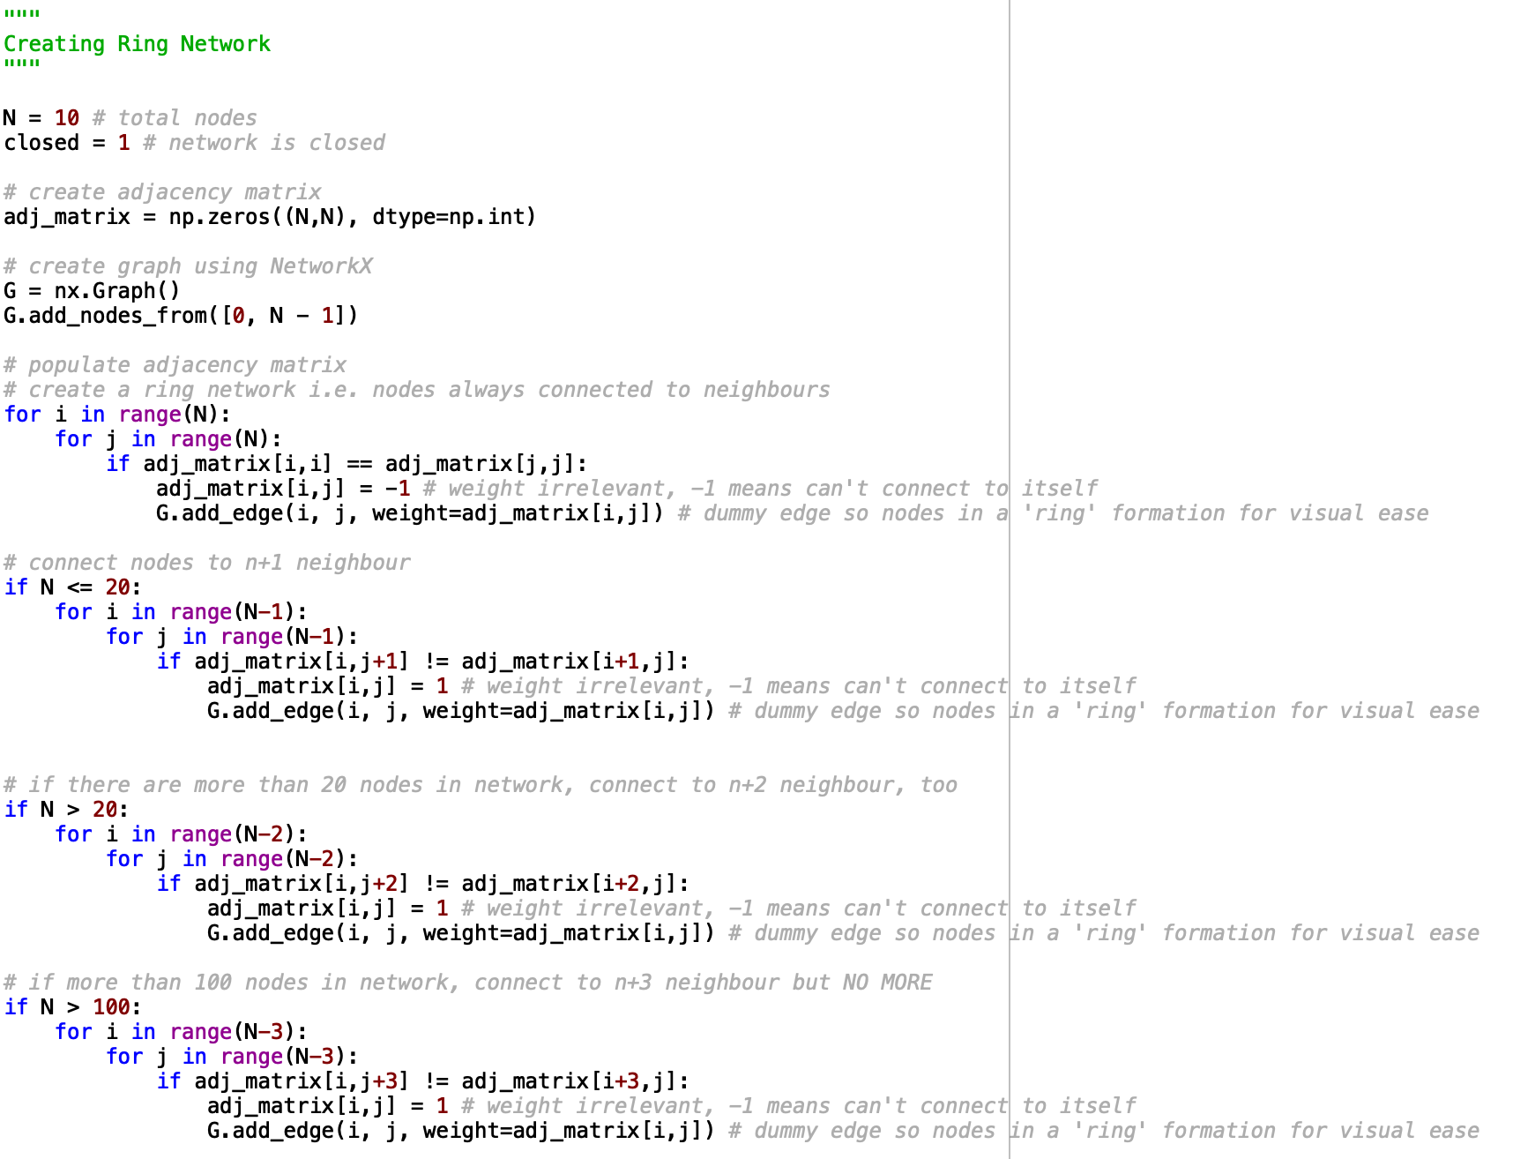

Once a ring network has been generated, connections between nodes can be re-wired at random to another part of the network.

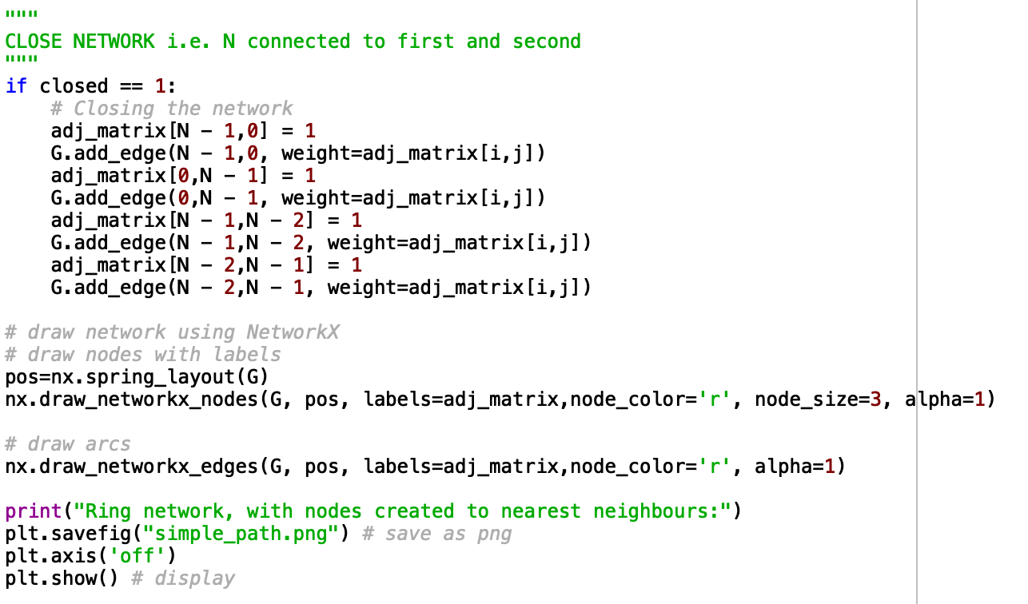

*The network will also need to be closed i.e. the last node in the network will be connected to the first, in order to properly represent a ring network.*

The following figures show the ring network created from the adjacency matrix and illustrated using the NetworkX package – the unusual topology of the ring network for the last node is due to the drawing method, but the mathematical representation remains solid.

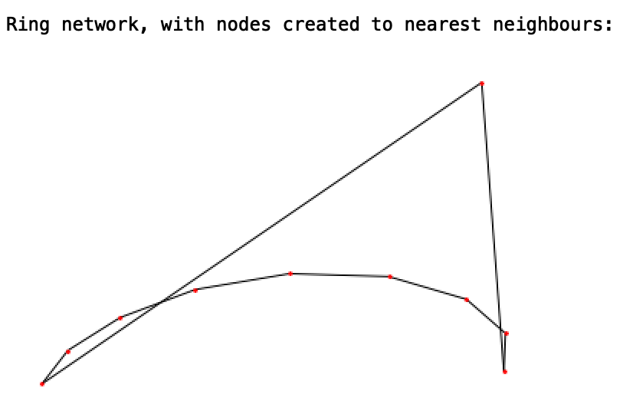

*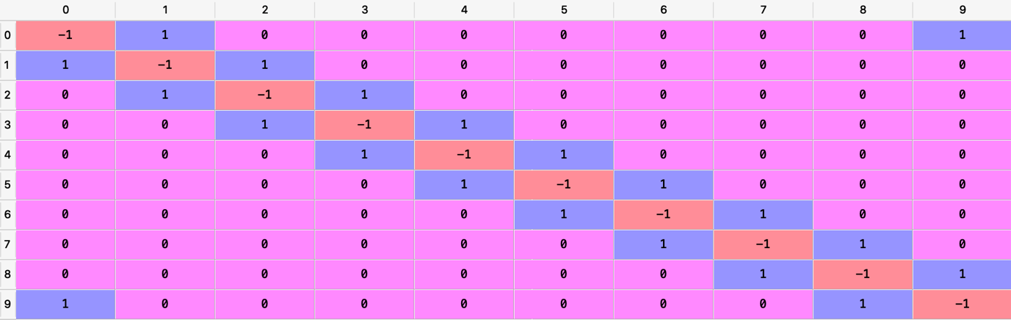  
For N = 10 nodes, illustration of network and the adjacency matrix are shown.*

As N increases, the adjacency matrix gets larger, so a screenshot will not fit within this document however the essential concepts are displayed above in the N = 10 example. N = -1 means no connection can occur (nodes cannot be connected to themselves in this sense), N = 0 means no connection present, and N = 1 represents a connection (an arc).

*Ring network with N = 50.*

*Ring network with N = 200.*

*Ring network with N = 500.*

To illustrate the small world effect, we will use N = 50 nodes. The Watts-Strogatz implementation of the small world effect considers a ring network of adjacently connected nodes, then removes a connection at random and rewires it to another node selected at random each pass. Continuing successive passes rewires the network such that one would only have to traverse six steps in order to move from one area of the network to the other; in other words, each node is reachable by a maximum of six other nodes in theory, according to Milgram’s small-world experiment (<https://en.wikipedia.org/wiki/Small-world_experiment>).

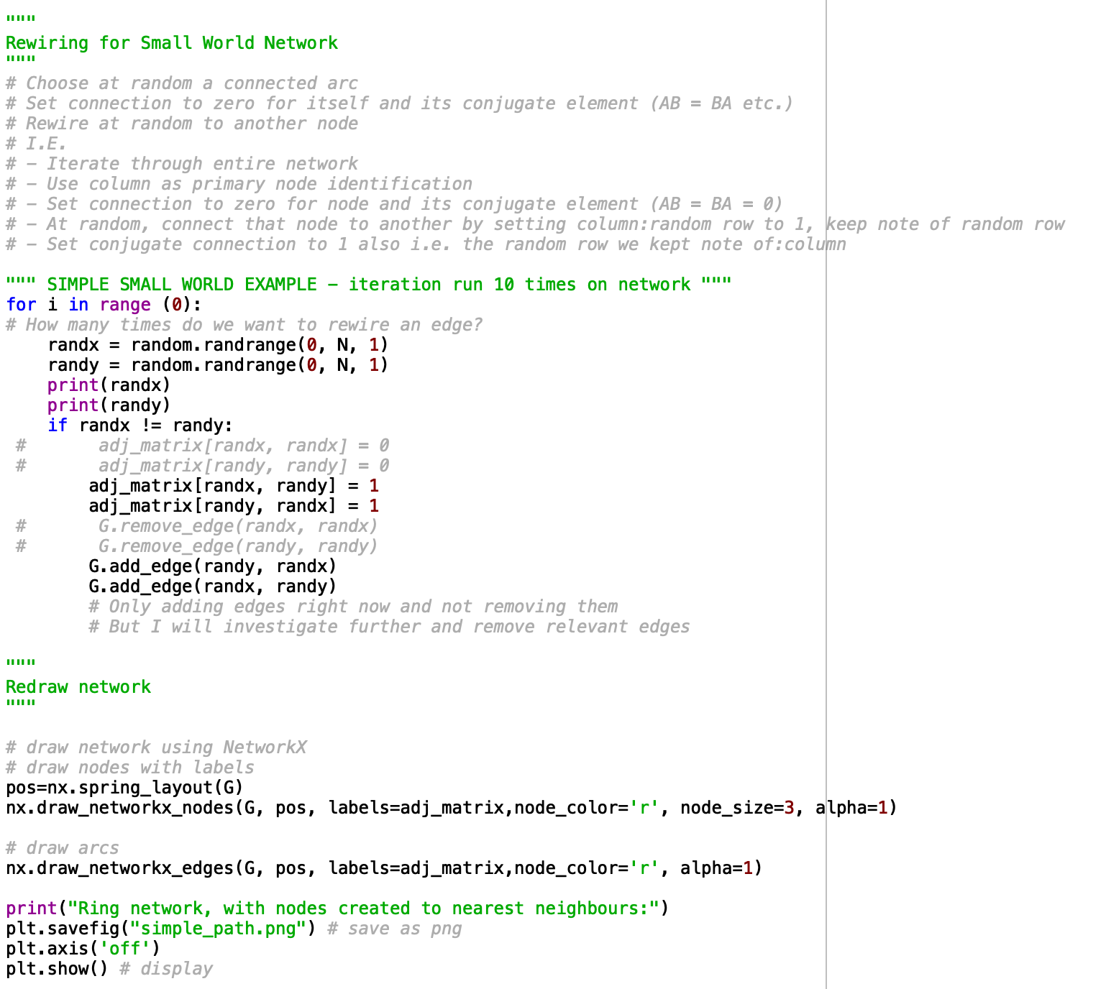

*The Small World subroutine included in the for-statement can be run as many times as required, and with each step, a connection is created from one side of the network to another selected at random. Rewiring may need to be necessary by removing the arc connecting the given node to another and rewiring it to that given node.*

The next step in this procedure is to remove an arc from the node (removing the connection between nodes A and B by removing arcs AB and BA) and rewiring it to a new node chosen at random. So far, the code only *adds* connections from a node to another, but does nothing in terms of rewiring (removing the old arc).

~~My logic here is to consider the node connections in the following steps:~~

* ~~Pick at random nodes A (beginning node) and C (final node)~~
* ~~Remove arcs AB and BA (an adjacent neighbour connection)~~
* ~~Create new arc AC and CA~~

~~This will result in the successful rewiring of the arcs within the network, creating a realistic small-world-network model that we can work with for later examples.~~

The small-world program has been rewritten and the code tidied up. The ring network is created with a more efficient method.

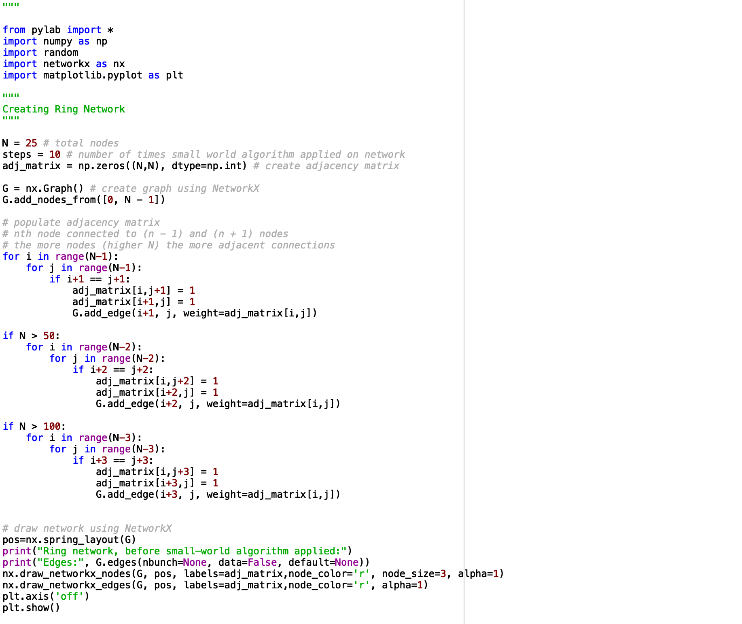

5/3/20. The small-world algorithm is revised and designed to be applied on the new ring network. The new code includes rewiring of edges (removal of original arc) and a display of a before and after illustration of algorithm applied to the network.

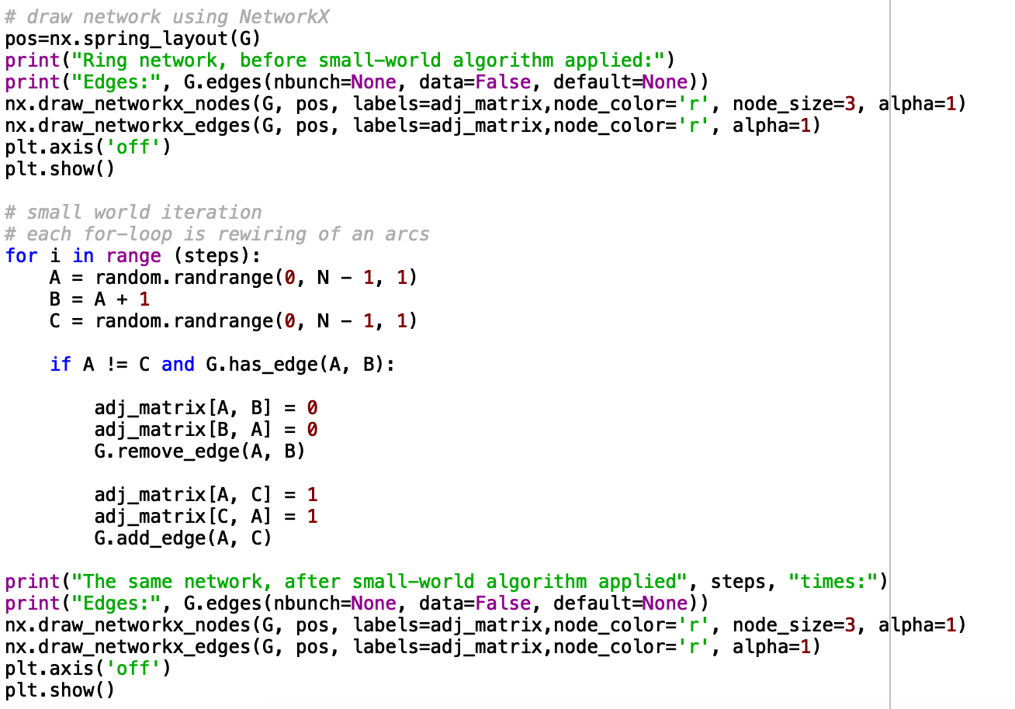

Here is the output generated with typical values of N = 30, and steps = 15 (small-world algorithm applied 15 times) on a ring network, with edges also displayed for clarity and debugging purposes:

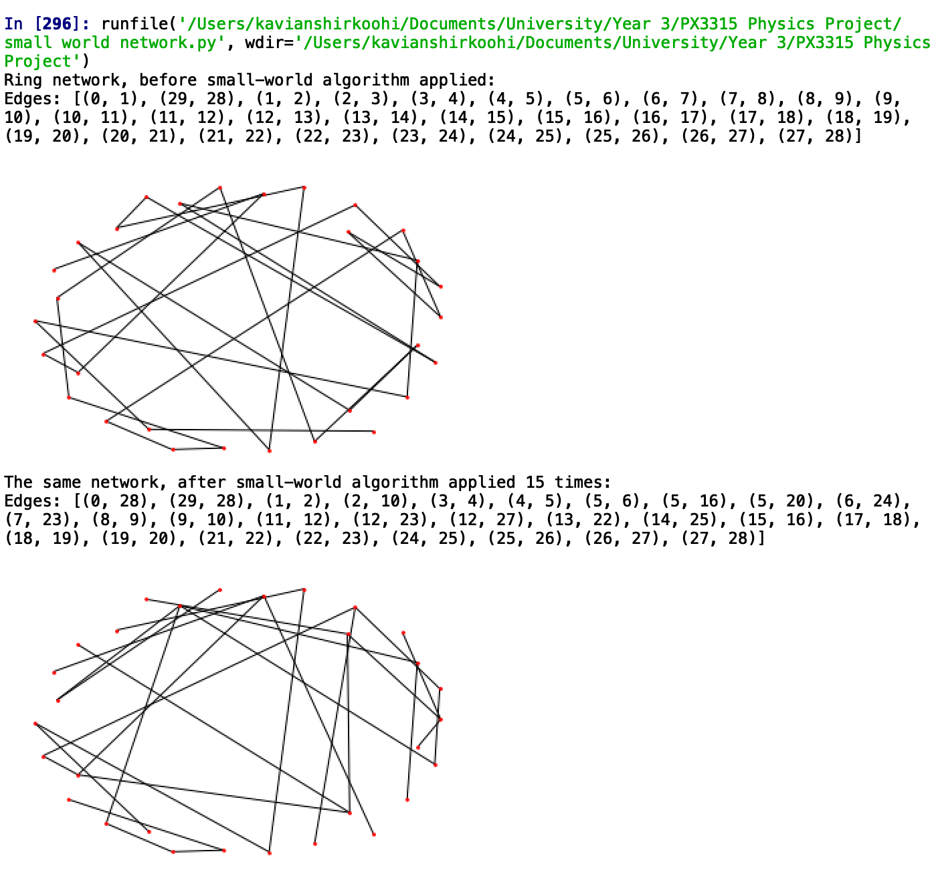

As expected, the network keeps the familiar location of nodes however rewiring is obvious, with an uneven distribution of order across the nodes in the network. Before the small-world algorithm was applied, all the nodes (save endpoints) typically had an order of 2 (connections to adjacent neighbours). After the algorithm was applied, some nodes had order 1, some order 5, and so on – the order was no longer regulated and a random distribution of node order across the network was now apparent.

**Scale-Free Networks**

With the scale-free network, the order of nodes increases with the growth of the network. That is, the more nodes there are, the more connections will be between them. The correlation between nodes and node order (i.e. amount of arcs connecting nodes between them) increases as to a power-law distribution, according to the Price model (<https://en.wikipedia.org/wiki/Price%27s_model> for my own reference). Price typically utilised the model for the representation of journal citations between academics – academics who were cited more often were more likely to be cited in future publications and so on.

To create a scale-free network, one would use the preferential attachment algorithm. The degree distribution (distribution of node order) in an undirected network, for large values of k, would be P(k) ∝ k⁻ˠ where P(k) is the fraction of nodes in the network having k connections to other nodes and ɣ is some parameter.

Some basic code and comments outlining what is to be covered next is included below.

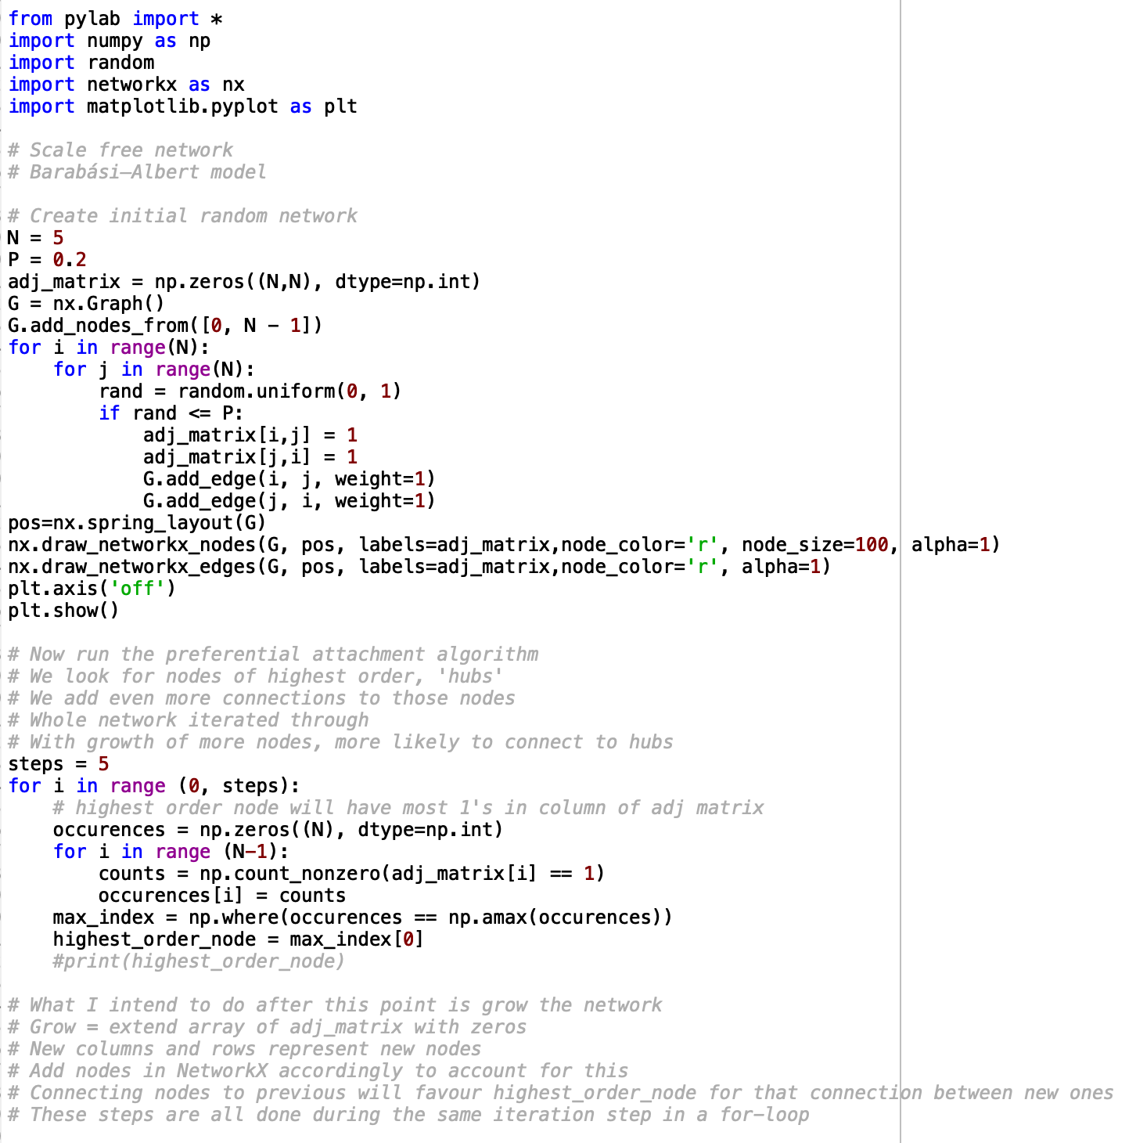

The Barabasi-Albert Model is to be used to grow the network. The next steps are to implement the preferential attachment algorithm in Python and include the growth and selection of highest order node in the same iteration package. From here on, the network could be grown to any desired size and a scale-free network could clearly display the clusters of nodes connected to ‘hubs’ and the degree distribution, using NetworkX to illustrate.

16/3/20 – Revisiting the scale-free network code. Also, must conduct a review of the applications of networks from the Stanford Large Dataset Collection website – a few ideas on what to model relative to the progression of the project.

16/4/20 – A new method of drawing the scale-free network. Consider an initial random network of nodes. Analyse the order of each node on the network. Create probabilities of connection proportional to the order of each node, so that the higher order nodes have a higher probability of connecting a new node to them than the lower ordered ones. This is a good abstraction of the preferential attachment algorithm. The drawback to this method is that there will be a performance bottleneck regarding scaling the network to a larger number of nodes. The entire network must be iterated each time a new node is considered to be added to the network, since the orders of the nodes may have changed randomly due to the probability nature of the attachment algorithm. And during each iteration, new probabilities must be updated in order to keep the algorithm consistent with the topology of the network.

Here is a short sketch of the idea behind the probability algorithm:

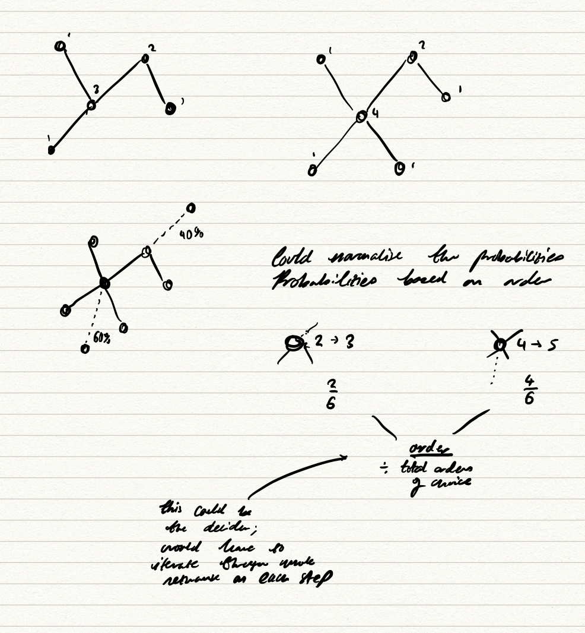

Pseudo-code for the network algorithm.

* Input the random network as old matrix
* Create a new matrix with dimensions + 1
* Fill new matrix with old matrix
* Iterate through old matrix and create array of [order, node]
* Create table of probabilities for node based on order
* Add connection in new matrix to node from old matrix based on probability
* Save this matrix as old matrix for next iteration

A more abstract code for the network algorithm is below.

* Input old matrix (N, N)
* For i in range (0, steps):
  + New matrix (N + i, N + i) as zeros
  + New matrix[i] = old matrix[i]
  + Create array probabilities (N + i)
  + For j in range (0, N + i):
    - Probabilities[j] = order of node/total order of all nodes
  + Trial probabilities, and unless trail number is < probability of node, connect to highest order node. Break for-loop in both cases
  + Set element [x, N + i] and [N + i, x] to =1 (connection)
  + Old matrix = new matrix (delete old data of old matrix so current becomes new)
  + Repeat and do again for next steps
* Return old matrix (given we have reached last line of code in the first-degree for-loop)

The above pseudocode is to be input to Python and a program generated.

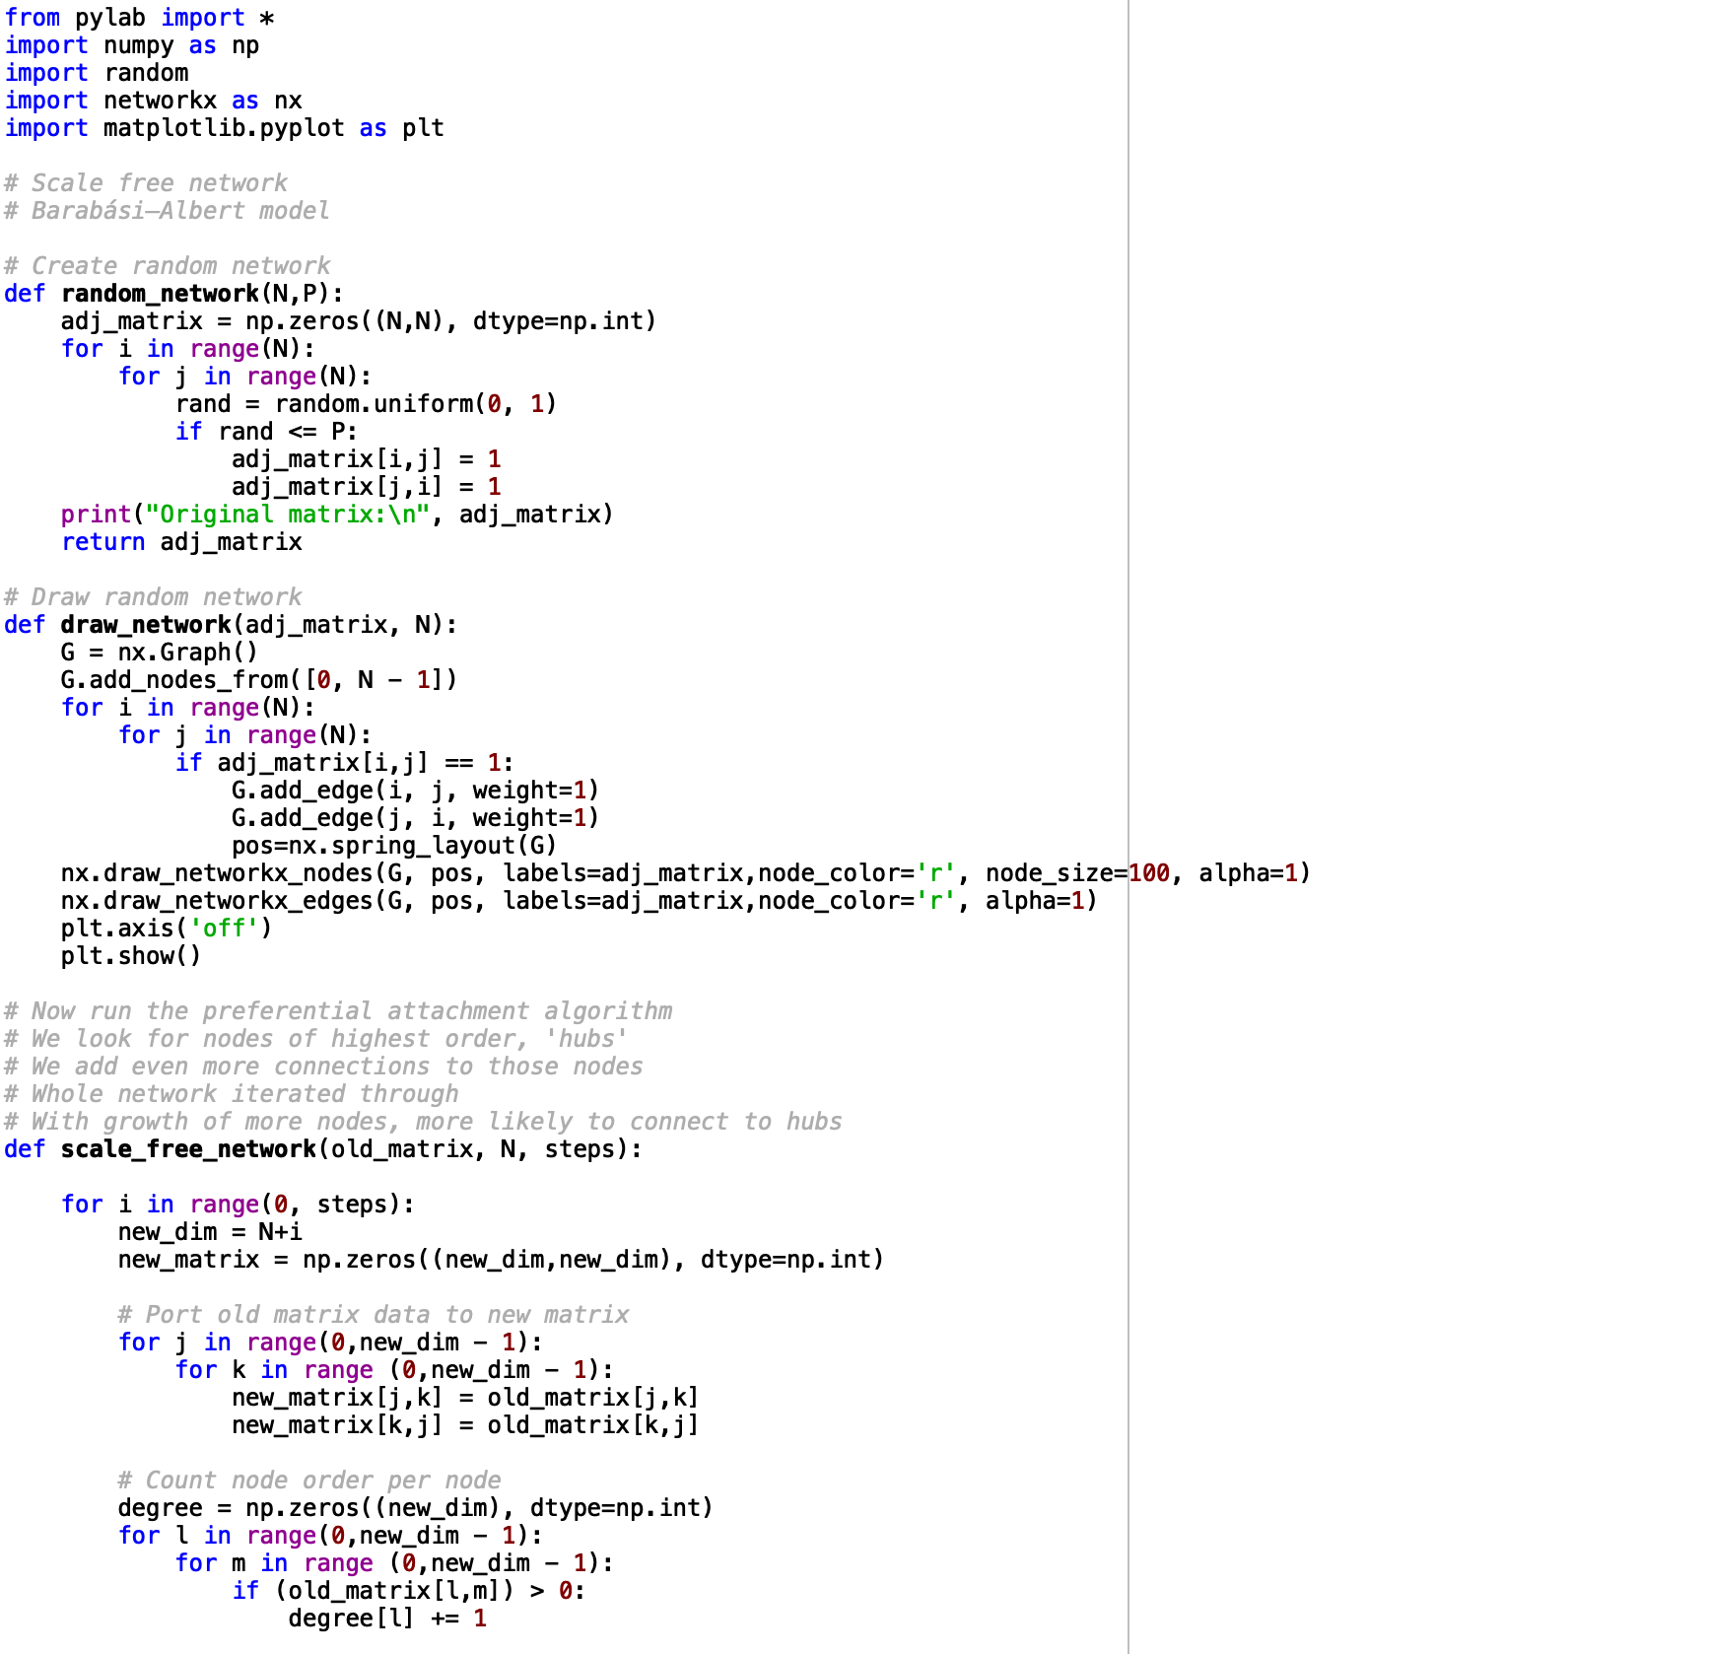

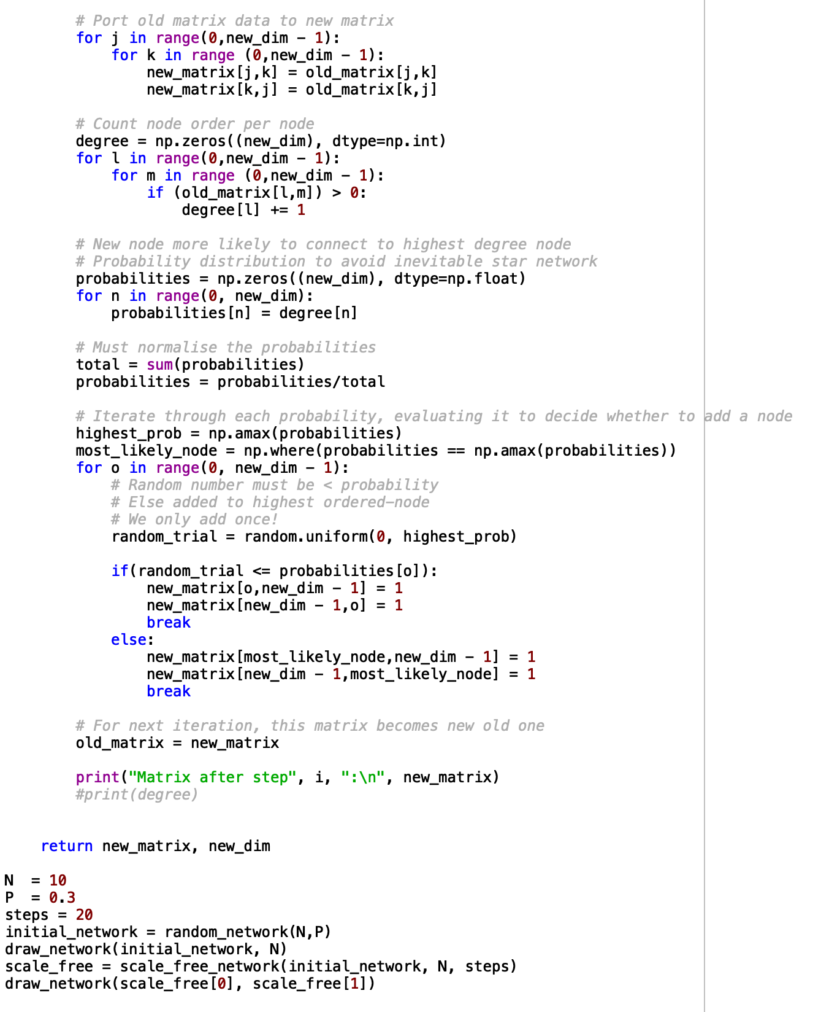

The above code generates a scale-free network, by creating a table of probabilities per node relative to the degree of each node. It then evaluates each probability against a random number that is generated with a range between zero and the value of the highest probability. This means that the highest probability node is default for connecting a new node to, should the random number falls short of probability of other nodes.

Below is the output generated by a deployment of the code, for steps = 20, N = 10 and p = 0.3 (the latter two being variables for the initial random network).

*The random network prior to the scale-free preferential attachment algorithm being applied.*

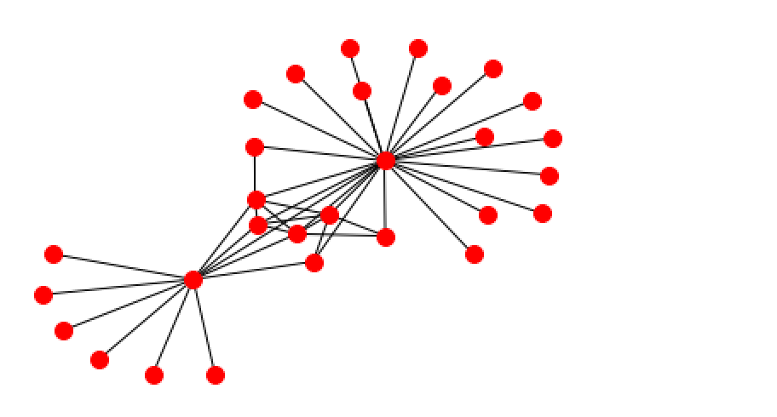

*The random network, after 20 iterations of the preferential attachment algorithm were applied.*

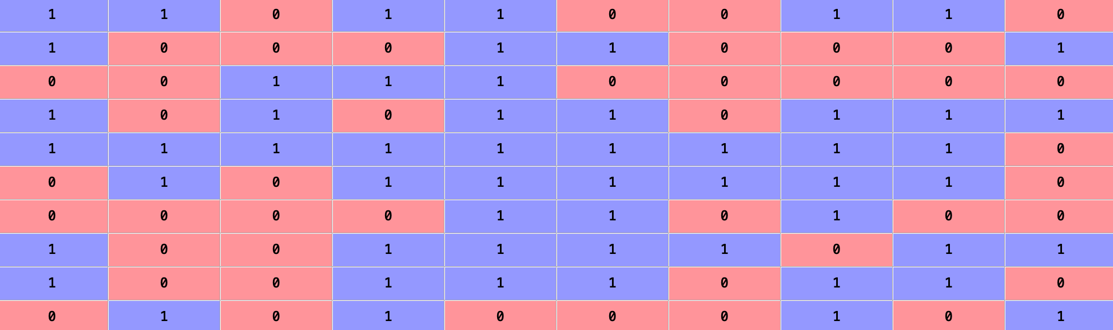

*The initial network’s adjacency matrix*

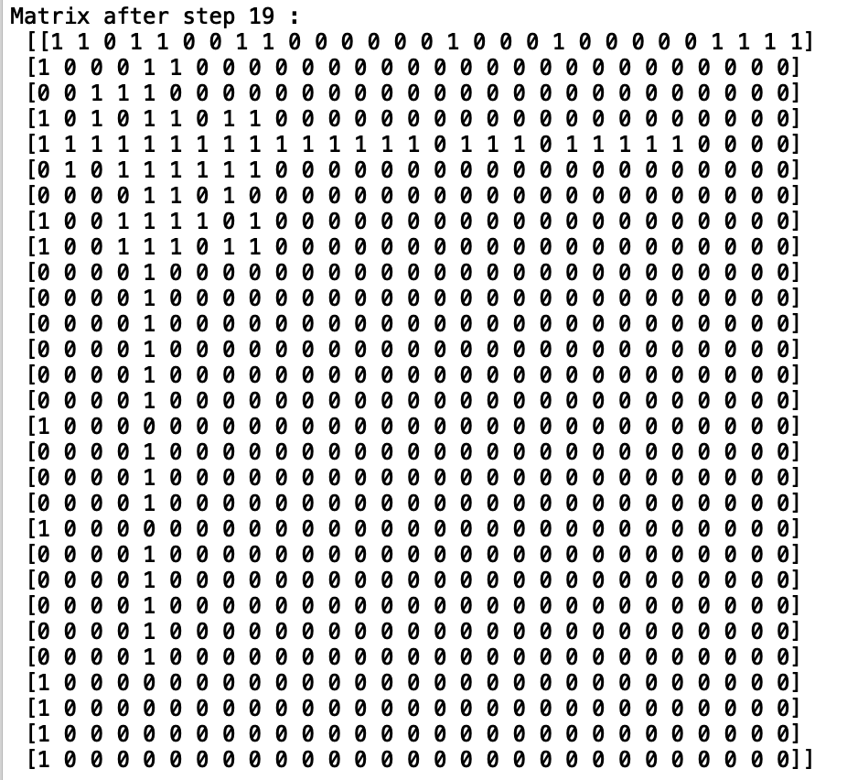

*The adjacency matrix after the steps were applied. Note the high clustering factor apparent from a high degree distribution; the higher-degree nodes with the more 1’s were more likely to receive even more 1’s than the lower-degree nodes.*

It is apparent that this whole setup can be simplified by removing the concept of a probability table altogether and relying simply on the value of a random number being less than the order of the node it has iterated through, with the highest-ordered node being present as the default. The code can be tidied up and for-loops minimised to save processing time, yielding the possibility to create larger scale-free networks.

A weighting factor, C, is used to decide how likely the added nodes will combine to the highest order node, or whether they will select other nodes at random. This factor, the larger it is, is proportional to the number of clusters, or ‘hubs’ on the network, effectively becoming the clustering coefficient. C must be between 0 and 1, as it is the probability of picking another node at random to add to rather than immediately preferring the highest-degree node. This prevents the inevitable star-network that would occur if the algorithm *only* added nodes to the highest-degree node after successive iterations.

*The undesirable star network. If there is no chance of picking other nodes in the network, the algorithm will continue to add nodes to the same high-ordered node, increasing the order of that node infinitely with absolutely no chance of any other node receiving a new neighbour. This would render the concept of different connected hubs, neighbourhoods, useless.*

*The same network with more iterations of the algorithm proves the network is no longer a scale-free complex network but a primitive star network with little interesting features.*

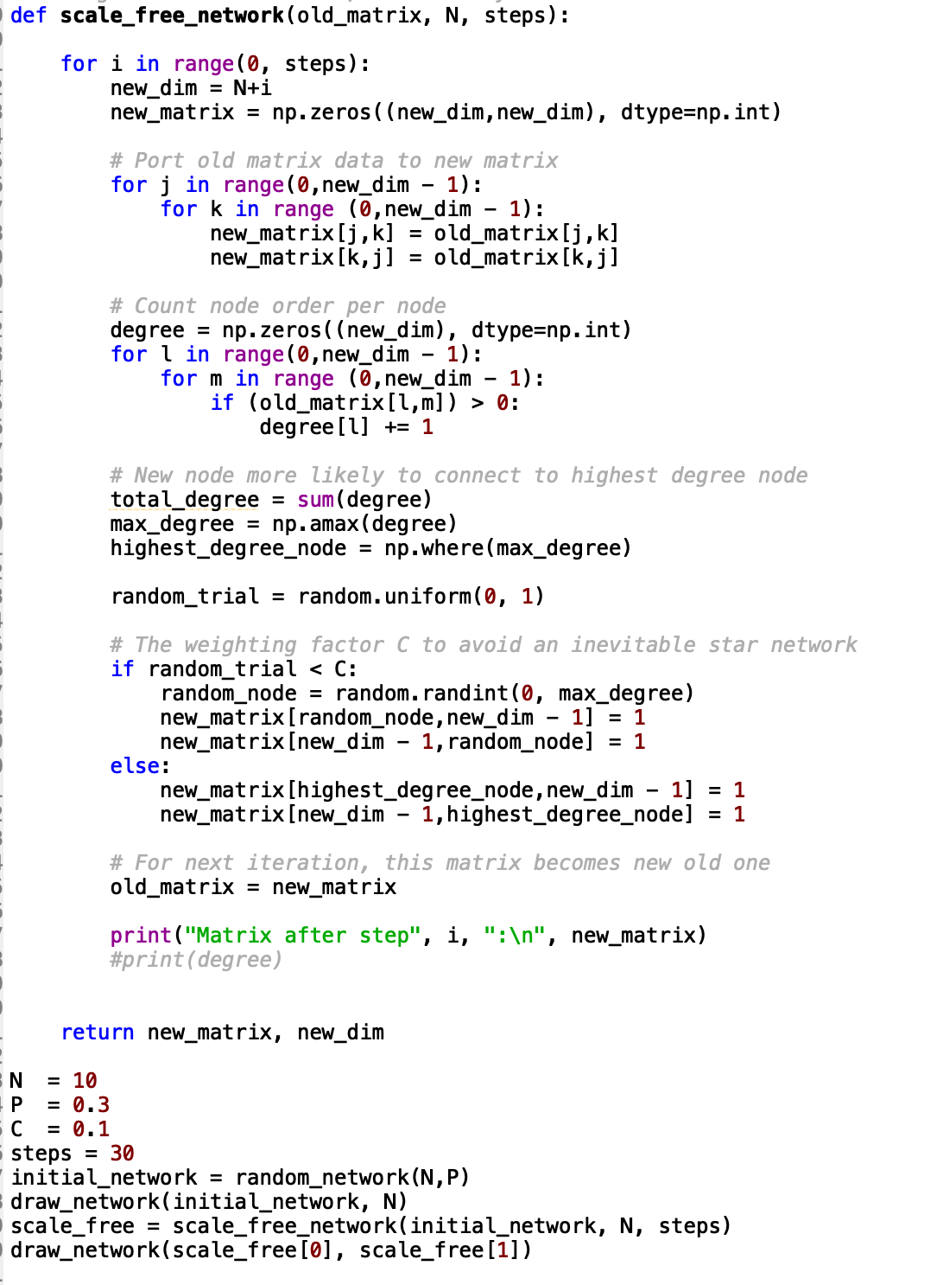

*The Python code implemented to work-around the star-network problem. The probability constant C is essential in order to give other nodes a chance at becoming hubs themselves. This results in the highest-ordered node being preferred for neighbour creation, but other nodes have a possibility of becoming high-ordered too.*

*A scale-free network with a low value of C = 0.1. Low degree distribution is apparent.*

*A similar network with a higher value of C = 0.5. Notice there are more hubs as the value of C increases, albeit lower-ordered than a single hub with the same steps would have been if C was lower.*

*The network with C = 0.9. Many small hubs can be observed. This makes C effectively proportional to the network’s clustering coefficient.*

Author note: Personally, I feel that the probability constant C doesn’t represent the scale-free network accurately enough. There needs to be a mention of clustering coefficients, assortativity, and degree distribution. Actual in-depth and thorough definitions and descriptions as they may be needed as an important characteristic of the networks I will be investigating later on.

8/5/20. A lot of the network code was created again from the ground up. Scale free and small world networks now reflect their real life counterparts.

**Project final notes**

**Due tomorrow 2pm**

* Scale free network
* Small world network

Real world data - input two examples, analyse them for their features.

* Degree distribution
* Measures of centrality
* Mean path length
* Clustering coefficient
* Robustness and percolation theory

Make educated comments about each and relate to the context of the data.

“In [graph theory](https://en.wikipedia.org/wiki/Graph_theory) and [network analysis](https://en.wikipedia.org/wiki/Network_theory), indicators of **centrality** identify the most important [vertices](https://en.wikipedia.org/wiki/Vertex_(graph_theory)) within a graph. Applications include identifying the most influential person(s) in a [social network](https://en.wikipedia.org/wiki/Social_network), key infrastructure nodes in the [Internet](https://en.wikipedia.org/wiki/Internet) or [urban networks](https://en.wikipedia.org/wiki/Urban_network), and [super-spreaders](https://en.wikipedia.org/wiki/Super-spreader) of disease. Centrality concepts were first developed in [social network analysis](https://en.wikipedia.org/wiki/Social_network_analysis), and many of the terms used to measure centrality reflect their [sociological](https://en.wikipedia.org/wiki/Sociology) origin.[1] They should not be confused with [node influence metrics](https://en.wikipedia.org/wiki/Node_influence_metric), which seek to quantify the influence of every node in the network.”

Create own code to calculate things like degree distribution (done), measures of centrality, MPL (done?) and clustering coeff. etc. - don’t think they want to see NetworkX code being used as it doesn’t demonstrate a robust understanding of the content. Instead, use NetworkX to check my code generates same thing.

**Project completion list**

* Analyse and compare analysis with scale free and small world
* Integrate all of this into the report
* Comment with help of academic paper on data results and relate to analysis
* Classify the network with reasonable judgement then conclude with ideas of more networks
* Compare them for scale free and small world
* Create network using real data
* ~~Create~~ *~~own~~* ~~functions for finding properties~~
* Establish main properties of complex networks

Main properties of complex networks:

* Robustness - percolation theory
  + Random vs. targeted attacks comment
    - What data do we show afterwards?
    - How are we going to simulate this?
    - How do we measure this?
  + Centrality - most important nodes, measure of importance
    - Closeness - avg. length of shortest path between node to rest i.e. transport link
    - Eigenvector - influence of node on a network; connections to higher value nodes i.e. knowing popular people
    - Betweenness - number of times node acts as bridge along shortest path between other nodes
    - Degree - density of links incident upon a node
* Assortativity coefficient - r +ve links nodes between similar degree, -ve more varied i.e. low degree with high degree with 1- < r < 1
* Clustering coefficient - local vs. degree
* Degree distribution
* Mean path length

Use NetworkX but heavily document how it works to explain clearly that I understand the methods.

Robustness - several ways of measuring it. An idea popped into my head re possibly measuring robustness by

* Number of disconnected nodes
* Average node degree
* Mean path length
* Robustness measure R =

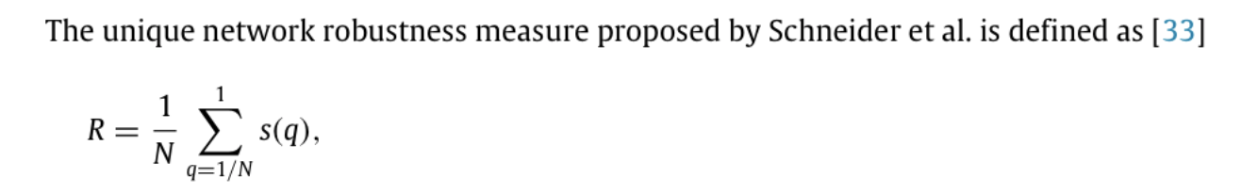

N = number of nodes, q = fraction of removed nodes, s(q) = fraction of nodes with largest connected component after removing qN largest degree nodes. Normalisation factor of 1/N.

(Cite this resource: [Efficient calculation of the robustness measure R for complex ...www.sciencedirect.com › science › article › pii](https://www.google.com/url?sa=t&rct=j&q=&esrc=s&source=web&cd=2&cad=rja&uact=8&ved=2ahUKEwjYv8LD9qLpAhWOQEEAHR8sCYYQFjABegQICxAE&url=https%3A%2F%2Fwww.sciencedirect.com%2Fscience%2Farticle%2Fpii%2FS0378437117301632&usg=AOvVaw3hFysJmNWQWvKw73MBnDu8))



Scale free good against random attack but vulnerable against targeted highest node attack.

Small world guarded against highest node attack as is more even degree distribution but random attack has more of an effect as whole topology needs to be rewired.

***Print layout and remove ‘2’ manually from abstract page before uploading!***

Idea for project could be Neural Networks. Stroke = one neuron area affected, other neurons unreachable; scale-free networks. Can apply to AI/ML.

AI/ML/neuroscience links could be really helpful in gaining deeper understanding for potential future career choices.